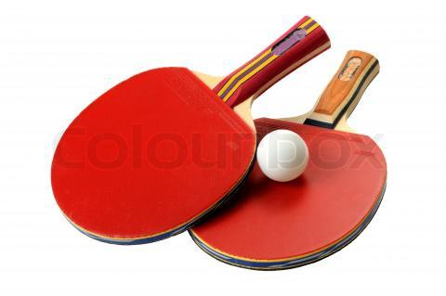

Minipuslinge Drenge
2005 Jacob Linnet
2007 David Jarsbo
2009 Jonathan Piilgaard
2010 Simon Gram Larsen
2012 Matias Gram Larsen

Puslinge drenge
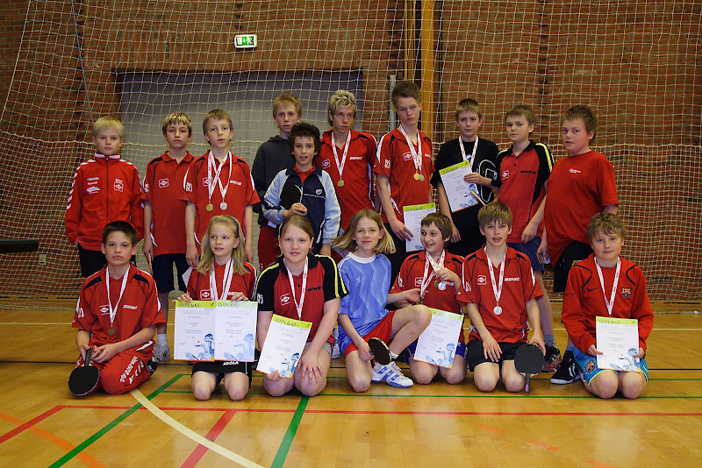
1983 Søren Skjoldhøj
1984 Lars Sørensen
1985 Simon Petersen
1986 Peter Larsen
1987 Jens N Pedersen
1988 Thorbjørn Andersen
1989 Thorbjørn Andersen
1990 Christoffer Jessen
1991 Michael Andersen
1993 Tue E Jensen
1995 Jannik L Jespersen
1996 Thomas V Glud
1997 Nick Sjørup
2001 Jannek De Place
2002 Peter Christensen
2003 Jannek De Place
2004 Anders O Gadeberg
2006 Jacob Linnet
2007 Frederik Vejlang
2008 David Jarsbo
2009 Mathias Bangsgaard
2010 Jonathan Pilgaard
2011 Simon Gram Larsen
2012 Simon Gram Larsen

Yngre drenge

1979 Lars Lund Sørensen
1980 Jesper Mørch
1981 Morten R Jensen
1982 Morten R Jensen
1983 Jesper Lybye
1984 Jesper Lybye
1985 Peter Lehm
1986 Lars Sørensen
1987 Anders Mørch
1988 Peter Larsen
1989 Joachim Rasmussen
1990 Jens N Pedersen
1991 Jens N Pedersen
1992 Christoffer Jessen
1993 Rasmus Lübker Andersen
1995 Jakub Funder
1996 Jakob Funder
1997 Jakob Kuupsdahl
2001 Mikkel S Lauridsen
2002 Søren O Gadberg
2003 Søren Christensen
2004 Søren Christensen
2005 Mads Baungaard
2006 Mads Baungaard
2007 Jacob Linnet
2008 Jesper Strøm
2009 Frederik Vejlang
2010 Casper Scram
2011 Sebastian Kjeldmann
2012 Sebastian Kjeldmann

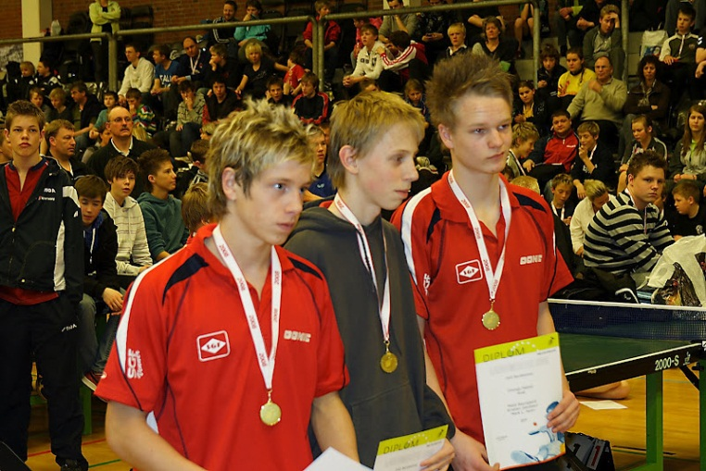
Drenge

1979 Peter Birch Hansen
1980 Claus R Jensen
1981 Claus Kirring
1982 Peter Lorentzen
1983 Peter Lorentzen
1884 Gynther Astrup
1985 Jesper Lybye
1986 Jesper Lybye
1987 Henrik Poulsen
1988 Lars Sørensen
1989 Peter Larsen
1990 Martin Simonsen
1991 Joachim Rasmussen
1992 Jens N Pedersen
1993 Jens N Pedersen
1994 Mikael Thye
1995 Jacob Skov
1996 Jørgen B Larsen
1997 Jacob L Funder
2001 Thomas Rasmussen
2002 Jens Frederik Trasborg
2005 Peter Christensen
2007 Mads Baungaard
2008 Marc Lellek Holm
2009 Mads Lerche
2010 Jesper Strøm
2011 Frederik Vejlang
2012 Casper Scram

Juniorer
1986 Gynther Astrup
1987 Thomas Sørensen
1988 Thomas Sørensen
1989 Jesper Lybye
1990 Henrik Poulsen
1991 Anders Mørch
1992 Martin Simonsen
1993 Anders Mørch
1995 Christopher Jessen
1996 Christopher Jessen
1997 Mikael Thye
1999 Jakob L Funder
2001 Jakob L Funder
2006 Mikkel S Lauridsen
2007 Mikkel Sommer
2009 Kristian Boye Jakobsen
2010 Kristian Boye Jakobsen
2011 Kristian Boye Jakobsen
2012 Jonas Fuursted

Årets Spiller
2006 Mathias S. Thomsen
2007 Kristian Boye Jakobsen
2008 Vestdanmarksserieholdet Drenge
Kristian Boye Jakobsen - Mads Baungaard - Marc L Holm
2009 Kristoffer Kjeldmann
2010 Mads Baungaard
2011 Simon Gram Larsen
2012 Jyske mestre – Puslinge A holdet
Simon Gram Larsen - Matias Gram Larsen - Oliver Ulrich

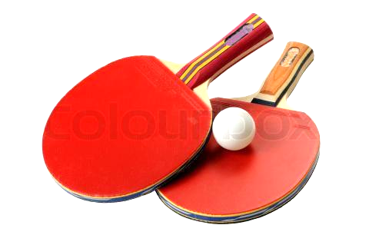
Herresenior(M+A /klasse 3+4)
1987 Michael Hvillum
1988 Jimmy Amdisen
1989 Jimmy Amdisen
1990 Ebbe W Jensen
1991 Ebbe W Jensen
1992 Jimmy Amdisen
1993 Jesper Mørch
1994 Anders Mørch
1995 Anders Mørch
1996 Peter F Jensen
1997 Joachim Rasmussen
1998 Anders Mørch
1999 Anders Mørch
2000 Anders Mørch
2001 Martin Nielsen
2002 Martin Nielsen
2003 Henning Mørch
2004 Henrik S Pedersen
2005 Henrik S Pedersen
2006 Henrik S Pedersen
2007 Henrik S Pedersen
2008 Henrik S Pedersen
2009 Henrik S Pedersen
2010 Martin Holten
2011 Torben Ulrich
2012 Morten Pedersen

Herresenior(B+C /klasse 5)
1994 Søren Østrup
1995 Søren Østrup
1996 Nick Harders
1997 Torben Johnsen
1998 Torben Johnsen
1999 Torben Johnsen
2000 Torben Johnsen
2001 Henning Laas
2002 Henning Wind
2003 Henning Wind
2004 Henning Wind
2005 Henning Wind
2006 Alf Thomsen
2007 Jan F Hansen
2008 Poul Kiilsgaard
2009 Jens Rosendahl
2010 Henning Mørch
2011 Henning Mørch

Damesenior
1994 Charlotte W Mørch
1995 Charlotte W Mørch
1996 Charlotte W Mørch
1997 Charlotte W Mørch
1998 Charlotte W Mørch
1999 Charlotte W Mørch
2000 Charlotte W Mørch
2001 Charlotte W Mørch
2002 Jette Østergaard Nielsen
2003 Jette Østergaard Nielsen
2005 Charlotte W Mørch
2007 Susanne Dinesen
2008 Charlotte Mørch

Minipuslinge Piger
2007 Kristine Strøm
2008 Emma Holmgaard Dybdal

Puslinge Piger
- Henriette Funch
- Henriette Funch
- Sandra Krogh Dinesen

Yngre Piger
2000 Nina Sørensen
2001 Nina Sørensen
2002 Sacha V. Jensen
2003 Sacha V. Jensen
2004 Henriette Funch
2008 Sandra Krogh Dinesen

Piger
1982 Anette Hansen
1983 Mette Pedersen
1984 Lene Hjortsøe
1985 Lene Hjortsøe
1986 Lene Hjortsøe
1987 Lene Hjortsøe
1988 Lisbeth Poulsen
1989 Lisbeth Poulsen
1990 Lisbeth Poulsen
1991 Lisbeth Poulsen
1993 Lise Kruse
1997 Pernille Brøgger
2002 Anja V. Jensen
2003 Anja V. Jensen
2007 Camilla Krogh Dinesen
2009 Sandra Krogh Dinesen

Nuværende klubmestre 2012

Minipuslinge Drenge
Matias Gram Larsen

Puslinge drenge
Simon Gram Larsen

Yngre drenge
Sebastian Kjeldmann
Drenge
Casper Scram

Junior
Jonas Fuursted

Herresenior(M+A /klasse 3+4)
Morten Pedersen

Årets Spillere
Jyske mestre – Puslinge A holdet
Simon Gram Larsen - Matias Gram Larsen - Oliver Ulrich

